

BICT.Honours in Information & Communication Technology

ICT1222 (P) Database Management Systems Practicum

Level 1- Semester 2 | 2022

Lecturer : Ms. Malsha

**Practical 4 Tutorial**

Name : H.P.G.L.P. Jayathilake

Student No : TG/2020/749

Department of Information & Communication Technology

Faculty of Technology

University of Ruhuna, Sri Lanka.

FACULTY OF TECHNOLOGY

UNIVERSITY OF RUHUNA

ICT1222 (P) Database Management Systems Practicum

**Practical 4**  **Tutorial** Level 1- Semester 2 | 2022

Student No: **TG/2020/749**

Student Name: **H.P.G. Lahiru Prasad Jayathilake**

***Exercise***

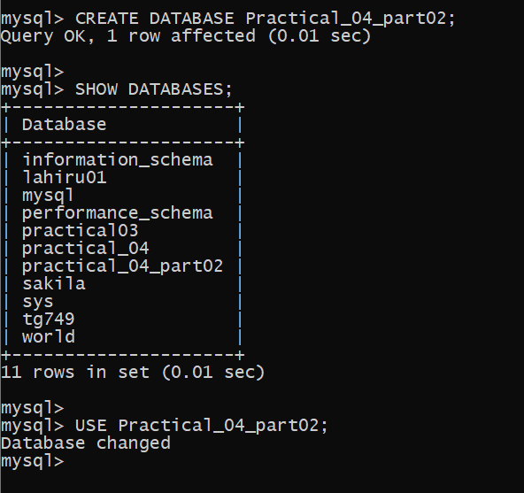

***Exercise - 01***

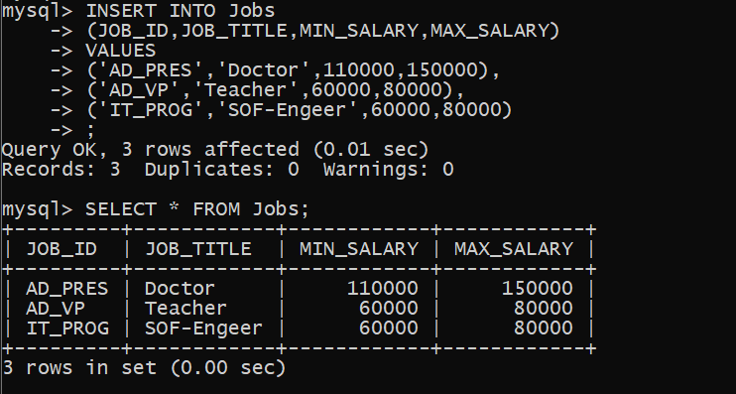

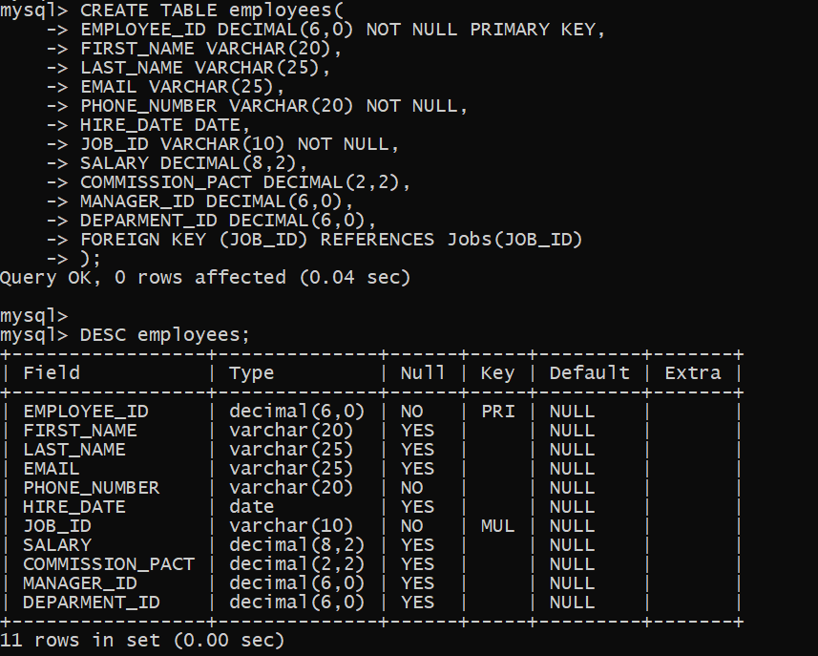

***Exercise - 02***

***Exercise - 03***

***Exercise - 04***

***Exercise - 05***

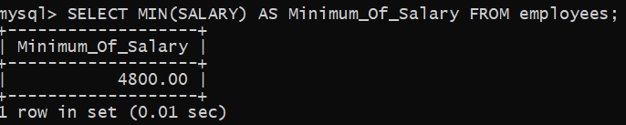

***Exercise - 06***

***Exercise - 07***

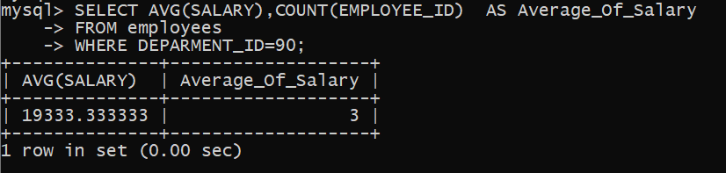

***Exercise - 08***

***Exercise - 09***

***Exercise - 10***

***Exercise - 11***

***Exercise - 12***

***Exercise - 13***

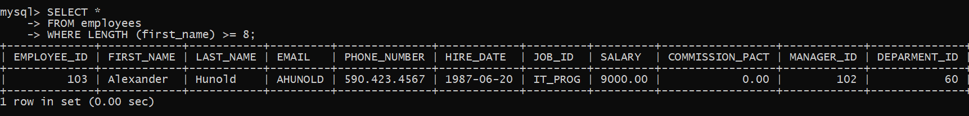\\

***Exercise - 14***

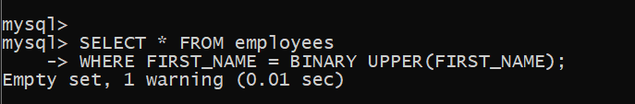

***Exercise - 15***

***Exercise - 16***

***Exercise - 17***

***Exercise - 18***

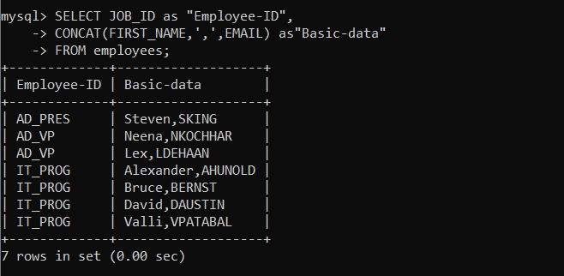

***Exercise - 19***

***Exercise - 20***

***Exercise - 21***

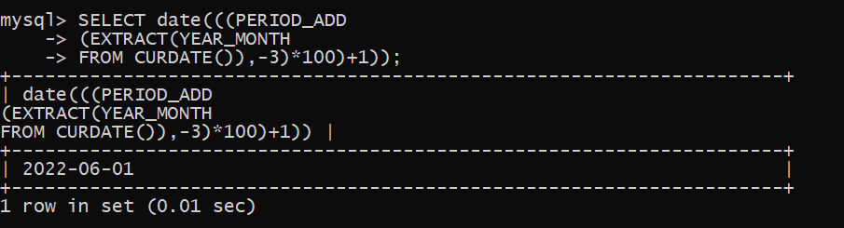

***Exercise - 22***

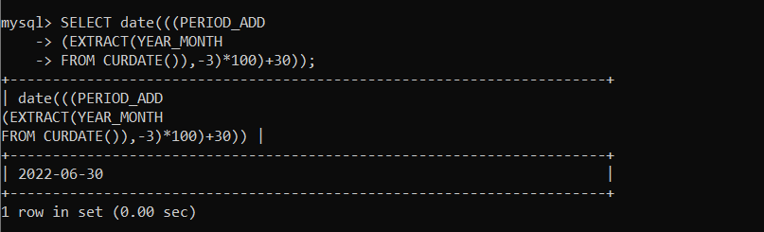

***Exercise - 23***

***Exercise - 24***

***Exercise - 25***

